CORRUGATED ESTIMATING

SET MATCHING MARKUP LOGIC

Network Administration Control Parameters

The SETPRINT decimal value field is used to define a mark up percentage for matching all parts of a set when calculating an estimate for a set. This may be modified when pressing the OVERRIDE GS&A button.

The CERUNC character value dictates the type of estimating that is calculated. For example, the Fibre format adds an available margin calculation based on commission percentage to determine the selling price. The salesman matrix provides a direct cross reference between available margin and commission percentage. For this example, we will assume 5% = available margin of 10% and 10% available margin = 8% commission.

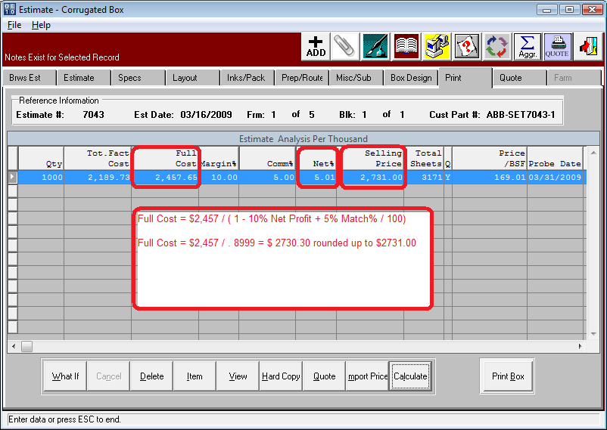
SELL PRICE CALCULATION

The estimates PRINT folder will show the factory cost, full cost, commission percentage, available margin, net profit and selling price.

Fibre Margin Formula:
The Fibre sell price calculation utilizes the commission percentage on the SPEC folder to find an available margin percentage.
The formula is as follows:
Full Cost less Commissions
/ 1 - (Net Profit Margin % + Match Markup % / 100)

For example for first component of Set.
Pre Commission Cost = $1204.42 /M per Thousand
Commission Percentage = 5.00
Net Profit Margin = 5.01
Match Markup = 5.00

$1204.42 / (1 – (5% + 5.01% + 5% / 100) ) = $1204.42 / (1-.84.99) = $ 1,417.12
Print Folder – View Button would display

T O T A L S in Cost/M 1,000
-------------------------------------------------
Direct Material 554.71
Direct Labor 292.55
Variable Overhead 84.77
DIRECT FACTORY COST 932.04
Fixed Overhead 204.21
TOTAL FACTORY COST 1,136.25
Broker Comm - 6.00% 68.18
Commission on SP - 5.00% 70.86
FULL COST 1,275.28
Net Margin - 5.01% 70.99
Available Margin - 10.00% 141.71
Matching Markup - 5.00% 70.86
SELLING PRICE 1,417.12
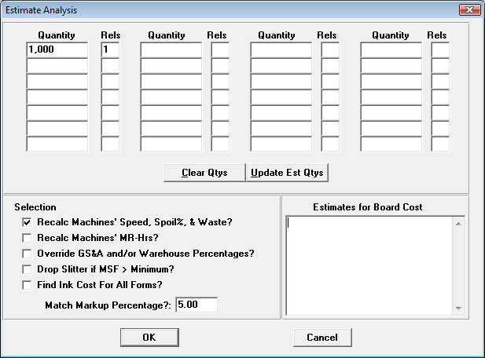

VIEW BUTTON

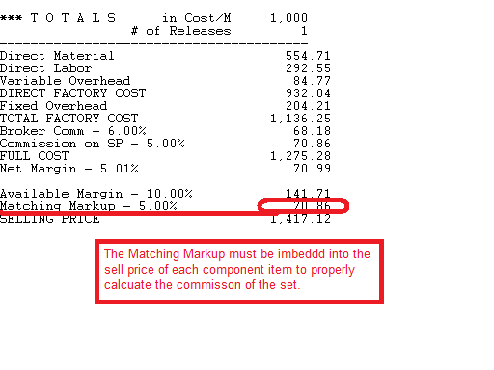

SET SUMMARY PAGE

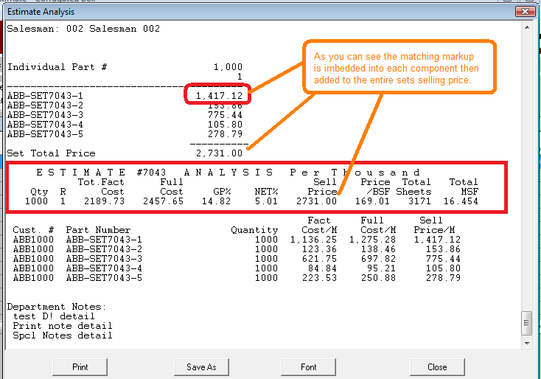

WHATIF Calculation

The system calculates the suggested Sell Price based on the commission percentage imported from the SPEC folder which transferred from the salesman matrix, unless a fixed commission percentage is defined in the customer file. In our example, the Full Cost includes commission. If the estimator changes the Available Margin to 20%, the program searches the sales matrix for the new commission percentage. In this example, the new commission percentage is 8%. The previous dollar amount must be substracted from Full Cost. Formula on Whatif when changing margin is as follows:
Full Cost less Commissions
/ 1 - (Net Profit Margin % + Match Markup % / 100)

*** T O T A L S in Cost/M 1,000
---------------------------------------------------------------
Direct Material 554.71
Direct Labor 292.55
Variable Overhead 84.77
DIRECT FACTORY COST 932.04
Fixed Overhead 204.21
TOTAL FACTORY COST 1,136.25
Broker Comm - 6.00% 68.18
Commission on SP 128.47
Commission % 7.00
FULL COST 1,332.90
Net Margin 192.79
Net Margin % 12.00
Available Margin 321.20
Available Margin % 20.00
Matching Markup - 5.00% 80.30
SELLING PRICE 1,605.99

